September 2024

MARKET UPDATE

As a reaction to weaker than expected jobs data, August began the month with a bout of volatility, where the S&P 500 experienced its worst three-day slide since June 2022 and its worst individual day since October 2022. All the volatility caused the CBOE Volatility Index (VIX) to blow past the 60-level intraday before settling around 38, levels last seen back in October 2020.

Rates fell across the yield curve throughout August, where the 1-year and 2-year experienced the largest declines in yield, starting the month at 4.74% and 4.26%, then ending at 4.40% and 3.92%, both respectively. The 1-month again held steady, only losing 11 basis points and still yielding the highest rate of 5.26%. The decline in rates pushed up bond prices and caused the Bloomberg US Aggregate Bond Index to end the month in the green, up 1.44%.

Since the jobs report was not as strong as expected, concerns arose over whether the Federal Reserve’s recent decisions to maintain two-decade high rates may risk a deeper economic slowdown than intended. As a result, Federal Chairman Jerome Powell voiced his concerns in Jackson Hole, stating that the time has come to adjust and lower the Federal Reserve’s key policy rate. Following the recent progress on inflation, Powel expressed his confidence on the sustainable path back to the target rate of 2%.

Consumer sentiment came in at 67.8, higher than then expected 66.9 and increased from the previous value of 66.4. Personal incomes came in higher than last month and above expectations at 0.3%, whereas personal spending also came in higher, but at expectations of 0.5%. With a cooling labor market, a stage may be set for income growth to slow in the coming months, which in turn may cause consumers to become more cautious with their spending and take some steam off economic growth in the latter half of the year.

ADVISORS’ PERSPECTIVE

Our research maintains a positive view of equities. The strength and duration of the S&P 500’s rally since last October, despite a few bumps in the road in April and more recently in late July through early August, has kept us in its positive stance. Overall, underlying metrics continue to be robust. Although softening a bit, macro-economic data supports GDP growth, which has allowed the market shake off recent unemployment concerns. Further, anticipation of a consistently less restrictive monetary policy from the Federal Reserve over the next 12 months is a tailwind.

The labor market has been showing signs of extreme gradual cooling for a little while now, though there haven’t been major cracks showing in labor market data yet. Despite the rise in unemployment rate that coinciding with August’s volatility, the rise was primarily due to more job seekers entering the labor market, not from any notable uptick in layoffs. In fact, layoffs remain close to multi-decade lows, though the consistent decline in people quitting their jobs is a concrete signal that the labor market has significantly cooled from its red-hot phase in 2021 and 2022. Despite anxiety over labor and employment data in early August, there were only small-scale movements across much of the economic data landscape over the month. However, those smaller movements have added up to show continuing softening.

Unfortunately, election years tend to bring out behavioral biases that can bring about investing mistakes and an uptick in client inbound questions to advisors. While tracking the odds can be helpful context to the overall picture, it may be a more useful barometer for investor anxiety, depending on their political persuasion. As indicated in the information below, the bottom line is elections should never be viewed as investable events, small sample sizes and correlation vs. causation run rampant in the articles and pundits that like to claim otherwise, who usually do it for clicks and viewers, not to help actual investors.

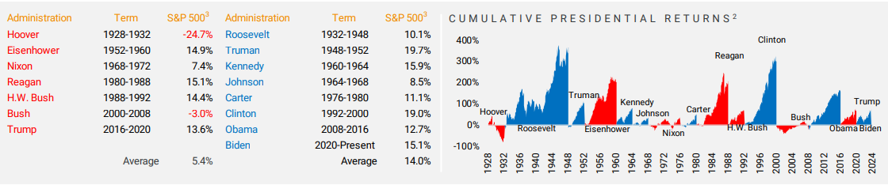

It is now the third bout of the market expecting the Fed to move to a significantly more dovish position. Previous cycles have been met with worse-than-expected inflation reports and the Fed reiterating its resolve to fight inflation. However, this time Fed Chair Powell is seemingly confirming at least near-term market expectations of a rate cut in September, the next FOMC meeting. In Jackson Hole he noted “the time has come” for policy changes. However, if the Fed doesn’t embark on an as-aggressive rate cutting cycle over the following several months, the market’s expectations may need to reset once again.

We remain cautiously optimistic and continue to use a quantitative investing approach. In times of uncertainty, it is more important than ever to follow the data and not make decisions based on emotions. Hilltops partnership with Helios relies on facts and data, which we use during our recalculations on a bi-weekly basis. Our models adjust appropriately to market conditions.

**DISCLOSURE**

This update is not intended to be relied upon as forecast, research, or investment advice, and is not a recommendation, offer, or solicitation to buy or sell any securities or to adopt any investment opinions expressed are as of the date noted and may change as subsequent conditions vary. The information and opinions contained in this letter are derived from proprietary and nonproprietary sources deemed by Hilltop Wealth Solutions to be reliable. The letter may contain “forward-looking” information that is not purely historical in nature. Such information may include, among other things, projections and forecasts. There is no guarantee that any forecast made will materialize. Additional information about Hilltop Wealth Solutions is available in its current disclosure documents, Form ADV, Form ADV Part 2A Brochure, and Client Relationship Summary Report which are accessible online via the SEC’s Investment Adviser Public Disclosure (IAPD) database at www.adviserinfo.sec.gov, using SEC # 801-115255. Hilltop Wealth Solutions is neither an attorney nor an accountant, and no portion of this content should be interpreted as legal, accounting, or tax advice.